**Git and Github**

To set the configurations of the person working:

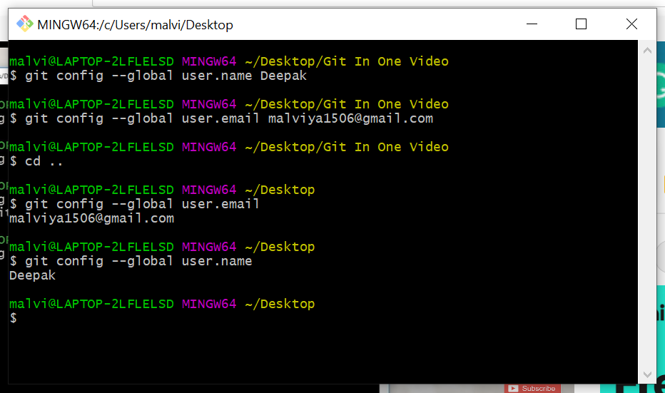

Open Visual Studio code by given command and initialize the git.

Check the folders and files present in the folder by the command

ls -lart

It will create a folder by name “git” where all the files will be available regarding git.

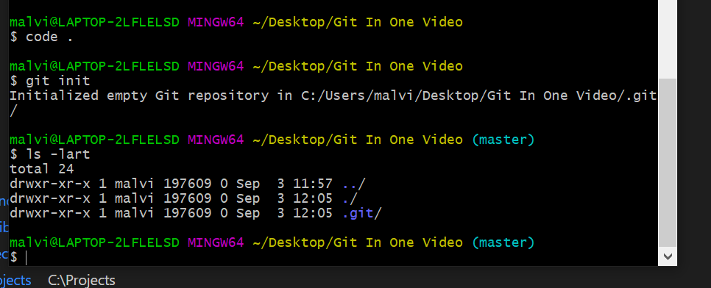

Here are the different status of Git files:-

1. **Untracked** – When Git not at all care about your file. You need to add this file to transfer it to Staged status.
2. **Staged** – When your file is in Git now, and ready to commit.
3. **Unmodified** – When your file is updated and absolutely fine. From here, we can either edit or remove the file.
4. **Modified** – When your file has been modified and want to get Staged and Commit to save the changes. From here, we should Staged and Commit the file. We can pass the file to Staged, but avoid commit if we want some time before commit.

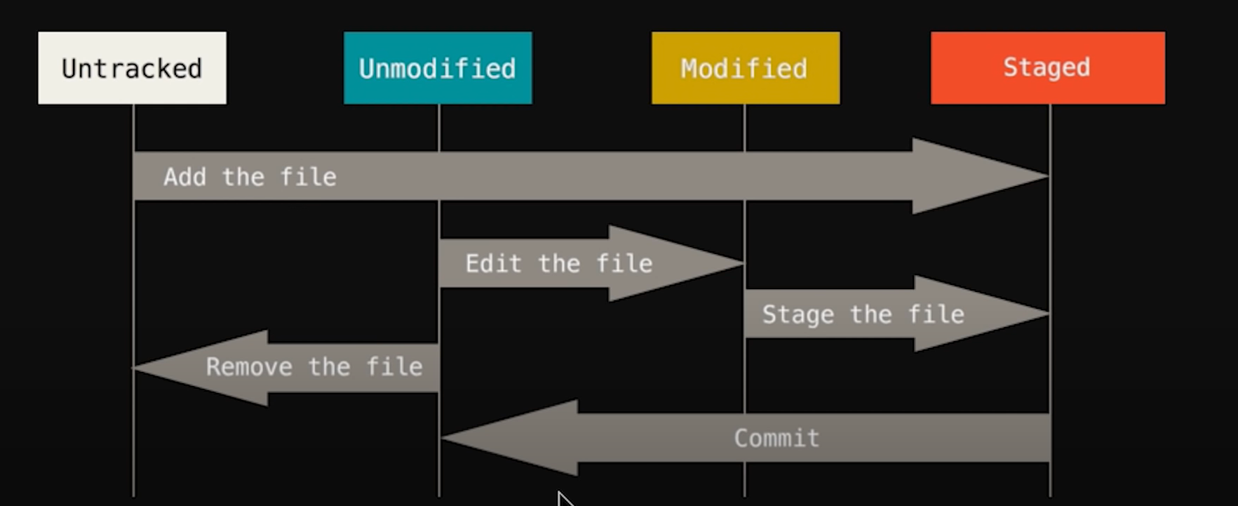

Just now, I have created a new file in a folder,

It is showing the status as “Untracked files”

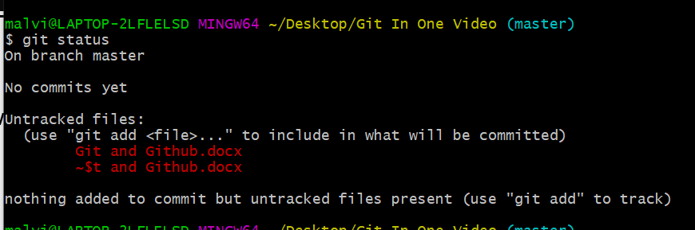

To Add it to Stage status, use below command,

Now, the Status is showing as “Changes to be committed”

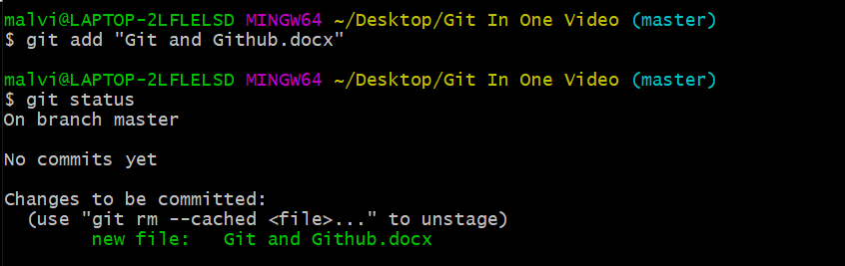

Always we should have an initial commit to save the structure. Click “i” to insert, and write “Initial Commit”

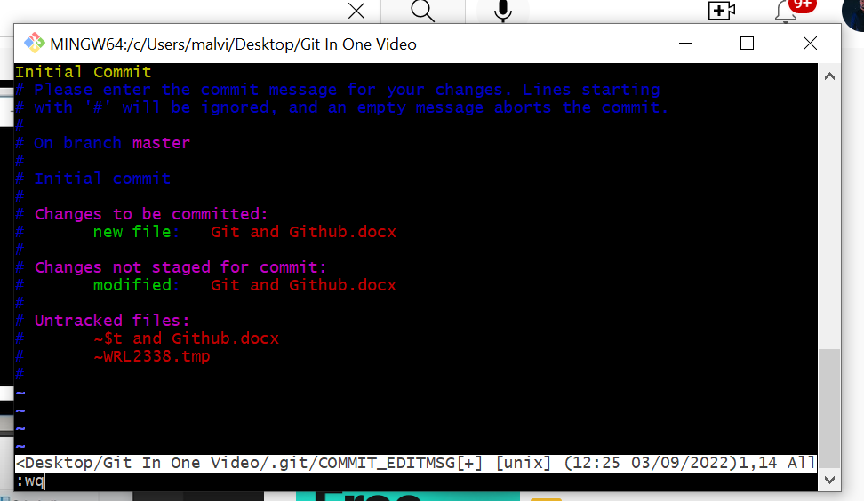

Esc+ “:wq” to exit